Pathology Requesting Dashboard A+E Report November 2016

- Overall Requesting Costs
(Actual calculated costs from finance will differ and this should only be used as a guide for the purpose of this report)
£19816.94 Estimated spend on biochemistry/haematology/Immunology tests by HoEFT A+E for October 2016. (Includes Good Hope and Solihull)
- Cost this month (£19816.94) -9.6% from October (£21929) -6.5% from September (£21217).
- Patient Numbers this month (11781) - 4% from October (12251) and +1.2% from September (11637).
- Request Numbers this month (31856) -8.6% from October (34881) and -1% from September (32140).
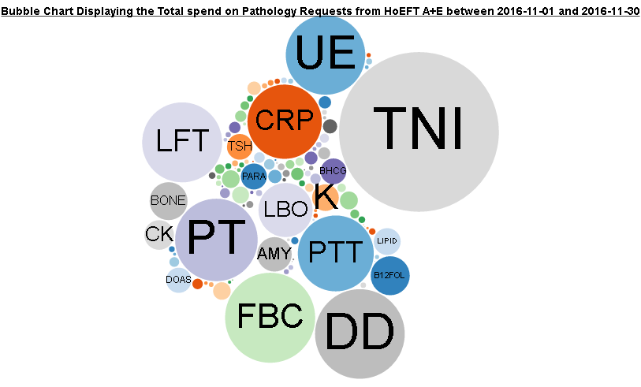
http://ebh24751:8000/graphs/costs_bubble/?start=2016-11-01&end=2016-11-30&view=spend&highlight=none
- Repeats
£73 was spend on A+E requests repeated within 180 minutes within A+E during November excluding troponin (£235 including) which is down from Octobers £124 (£393 including Troponin).
This only represents samples charged to A+E pathology twice, the actual figures for retesting between departments is much higher.
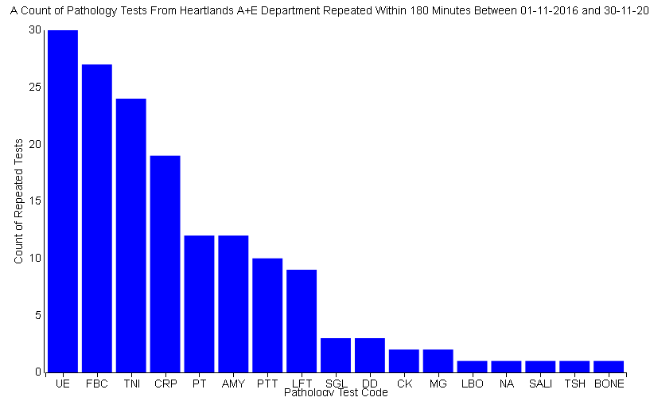
http://ebh24751:8000/graphs/repeats/?start=2016-11-01&end=2016-11-30&mins=180

- Add-on tests
£753 extra was charged to A+E in November for tests added on more than 4 hours after the initial test. This is a decrease from the £999 extra added in October.
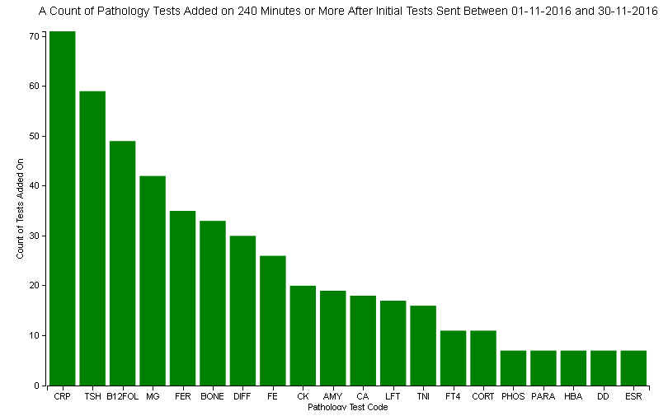
http://ebh24751:8000/graphs/addons/?start=2016-11-01&end=2016-11-30&mins=240
Investigating this in further detail we can see that the biggest cost comes from B12 and Folate addons (£145).
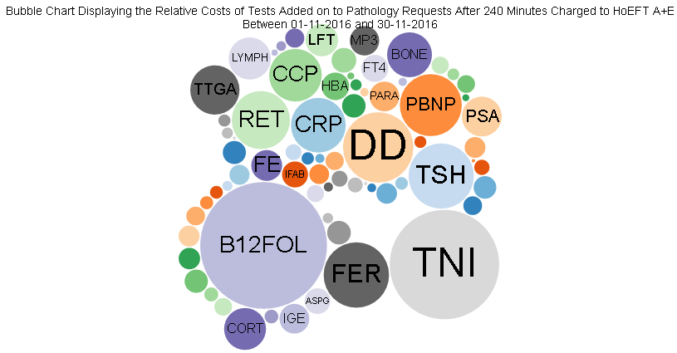
http://ebh24751:8000/graphs/addons/cost/?start=2016-11-01&end=2016-11-30&mins=240
- ICE Requesting
67% of A+E pathology requests made during November 2016 were made electronically through ICE requesting, an decrease on the 70% seen in October
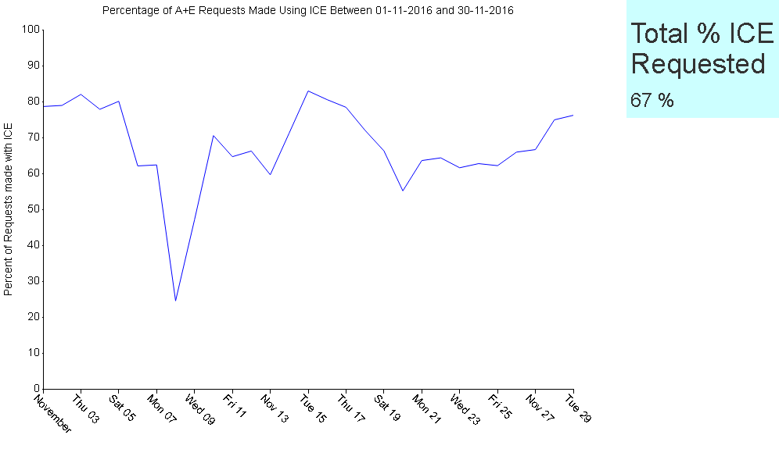
http://ebh24751:8000/graphs/ice_n/?start=2016-11-01&end=2016-11-30
- Investigating Bundles
Within ICE requesting for A+E there are several pre-defined testing bundles designed to be used for specific patient presentations. We have investigated the data we have with respect to these bundles to work out if anyone is using them.
The bundles we chose to investigate were ‘Acute Coronary Symptoms’, ‘First Fit’ and ‘Stroke’. Explanations of the calculations used to define patients groups were included in the October report which can be requested from pip.croxford@heartofengland.nhs.uk.

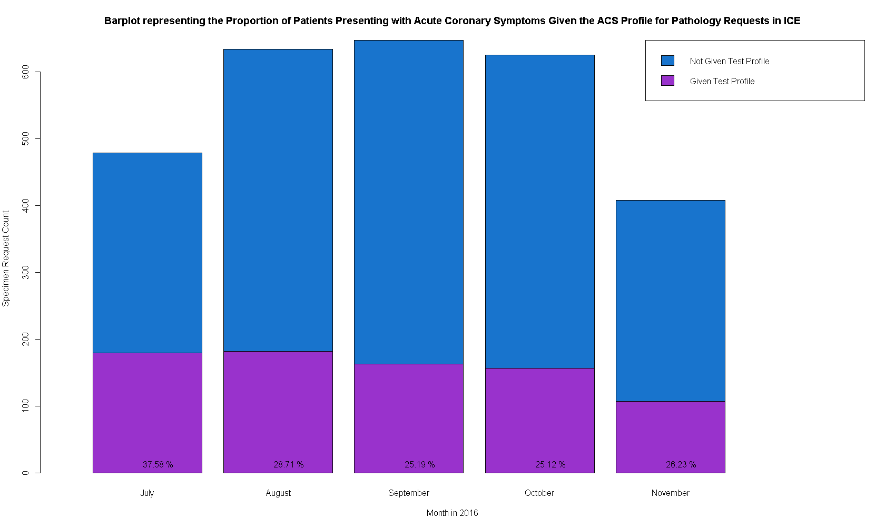

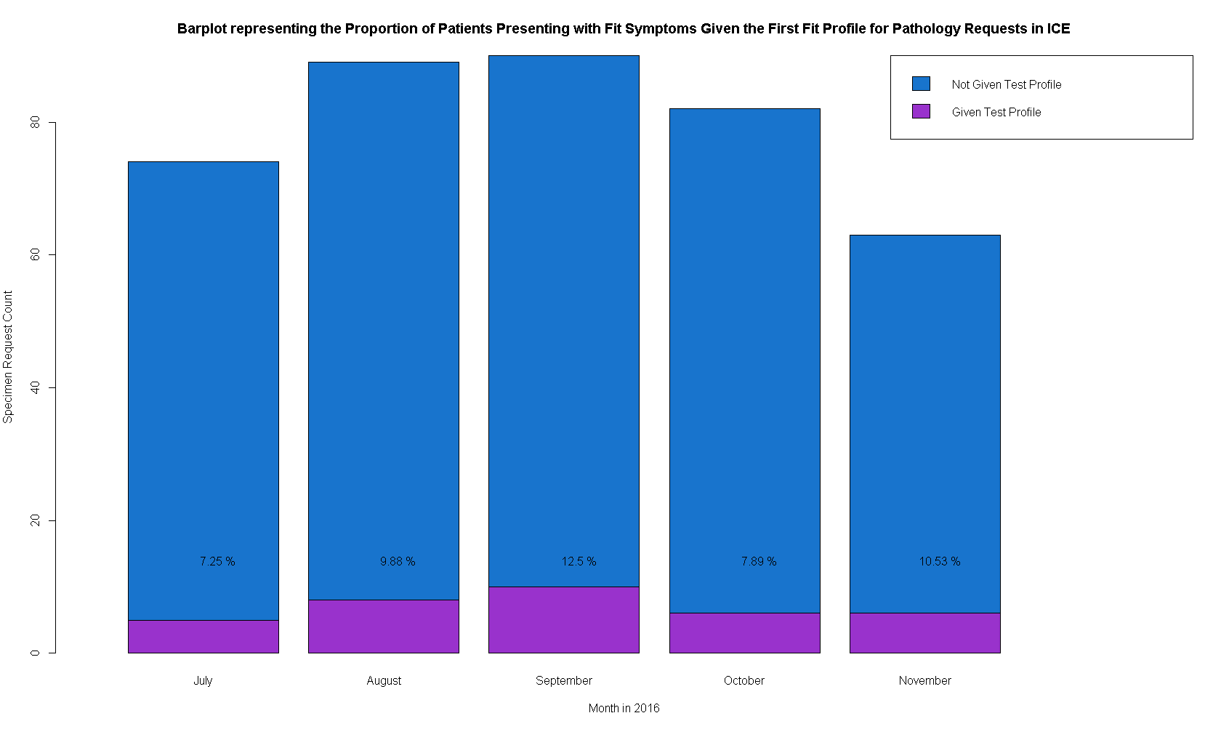

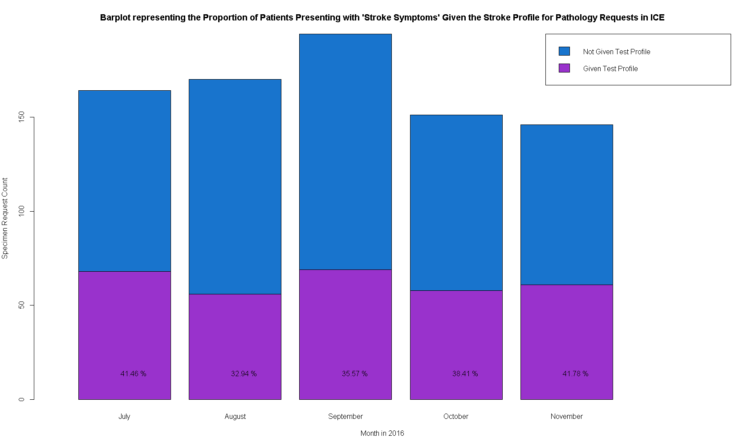
None of these bundles showed any particularly sgnificant increase or decrease in use this month.
Contact Details
This report was created by Pip Croxford as part of an MSc in Health Informatics for the University of Manchester. She will happily answer any questions and would be grateful for any feedback.
Email: pip.croxford@heartofengland.nhs.uk
Ext: 52956

